LA Lesson Plan #1

Grade Level: 1st grade
Subject(s) Area: Language Arts: Central Idea
Materials Needed:
- Chester’s Way by Kevin Henkes, chart paper, markers, pencils, clip boards, Graphic organizer
Standards:
RL.1.2 - Retell stories, including key details, and demonstrate understanding of their central message or lesson.
Objectives:
The learner will analyze the key details of the story to infer the central message.

Learning Activities:
(25 minutes)
- On the board the teacher will write the learning target: I can find the central message of the story.
- The teacher will present the central message anchor chart to the class.
  - 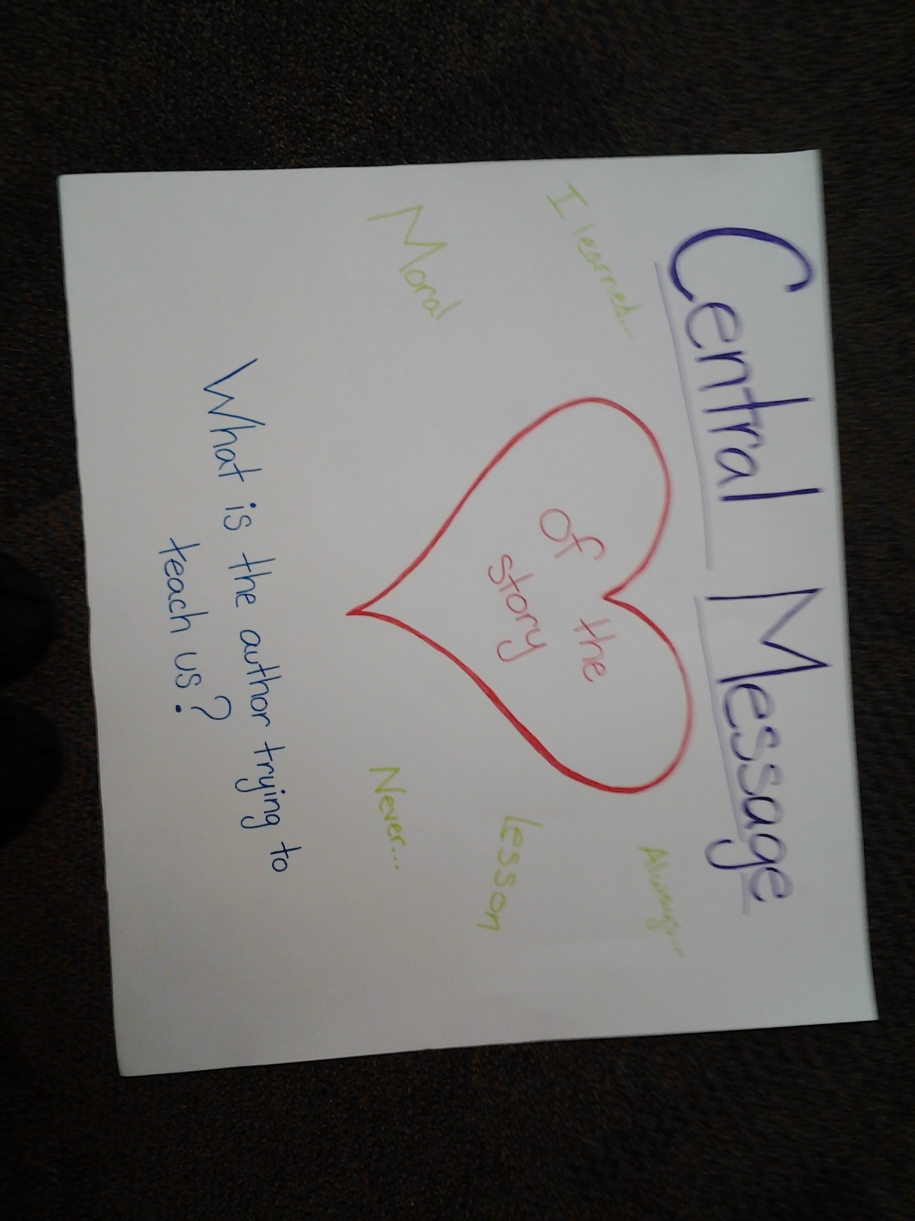
    - What is the author trying to tell or teach us?
    - Connect to inferring
    - Students will turn and talk about inferring and key details. (1 min)
- Read Chester’s Way
- Fill out graphic organizer as class.
  - Students brainstorm/write key details on own paper (4 min)
  - Students turn and talk about ideas (1 min)
  - Students share details as teacher writes them on the board
    - Cold call students
  - Students infer what the central lesson is
    - Turn and talk with neighbor
- Review with assessment

Assessment:
- Review central message
  - Call students up by similarities to put clip boards away
  - The student finds one of these people and tells them what the central message of a story is.

Reflection:
I think that overall this lesson went pretty well. It was my first lesson in an actual classroom. I think that I opened the lesson well and kept the students engaged while reading the story. I was able to keep the students from playing with the clipboards and pencils by telling them my expectations of what first graders can do. If I were going to teach this lesson again I would keep this plus the anchor chart. I like the heart of the story part. Also, I think that the turn and talk points worked well so those would also stay. The story Chester’s Way would also be kept, because the central message was easy enough for the students to figure out while not being a bland story.
There are definitely some things that would be changed. I’m not sure if I would keep the graphic organizer. If I used a paper it would need separate places to write details for the beginning, middle, and end. The other option would be to use sticky notes and to have a different sticky note for each part of the story. I think the separation of parts and details would help the students with order and inferring the message. They would not have to worry about spacing either. If I did this again I would reference the chart more. I did not use it as much as I could have today. It kind of went to the back of my mind. I would also find a way to cold call on different students. Perhaps name sticks are a way to do that. Along with this the wait time I used needs to be increased. I got to hurried and wanted to do what was next, but not all kids think at the same pace. I shortchanged some of them today. More patience was needed. I think that is why I called on some of the same kids a few times. The other big thing that I would change is the end of the lesson. Instead of just collecting the papers I need to wrap up our time by summing up the information. This way the beginning would connect with the end, and the students leave thinking about the topic of the lesson. Repeating the objective of the lesson will help drive the lesson home and it will be remembered. This recap could be something as simple as having the students tell a partner what the central message of a story is while they hand in papers.

Name: ____________________________
Date: ______________________________
Central Message
______________________________________________________________________________________________________________________________
Key Details
_________________________________________________________________________________________________________________________________________________________________________________________________________________________________

