Focal Point & Line Collage

Grade Level: 1st grade

Subject(s) Area: Visual Art

Materials Needed:
Scissors, glue sticks, pencils, white sheet paper (1 each), black construction paper (strips or ¼’s), assorted colored construction paper (cut in ¼’s), board and marker, 8 works of art, Lines that Wiggle by Candace Whitman

Standards:
4.1.2 – Know the different techniques used to create visual art.
4.2.1 – Know the differences among visual art structures and functions.
Objectives:
Students will identify the focal point of different works of art. Students will classify the different types of lines. Students will create a collage of lines and a shape.
Learning Activities:
Intro activity:
- Read book Lines that Wiggle
- Create line anchor chart with kids
- Have the students turn and talk and describe the different types of lines that they know.
- Discuss each type of line and have the students trace it with their finger in the air
  - Find things in the room with that line
- Discuss focal point
  - It is like the main idea of the art piece.
  - The focal point is what the artist wants you to notice and look at
  - The artist is emphasizing that part with more color, bigger size, or different colors.
- Display each painting one at a time and ask: What do you think the focal point of this painting is? Why do you think that? What types of lines do you see?
- Show the example of the day’s art project

Collage Project:
- Have students sit in desk while explaining.
- Show the example collage again
- Tell the class that this is what we are going to make today
  - Each student will get one white sheet of paper and 2 strips of black construction paper (1 long and one short)
  - You will get to choose one piece of colored paper for your focal point
  - You will cut out lines from the black paper and they can be any type of line.
    - If you need some ideas look at the chart.
  - You will then cut out the focal point from the colored paper you chose.
    - This can be any shape that you want. It can be geometric like a square or circle or made up by you.
    - You can lightly draw the line or shape with a pencil if you want to first.
  - Once you cut out the focal point and all of lines arrange them on the white paper however you like them. They can even overlap if you want.
  - When you find an arrangement that you like glue the focal point and lines onto the white paper
- While some students are getting their black and colored paper have the others take out their scissors and glue sticks and hand out the white paper.
  - Have students get paper in groups of four
- Have students write name on back of the white paper
- Let the students begin
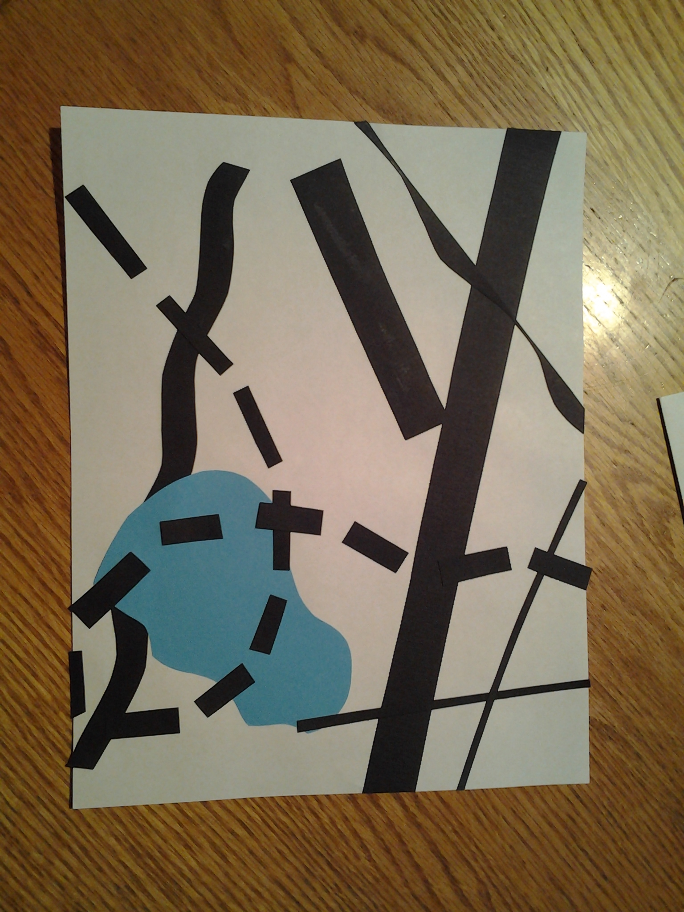
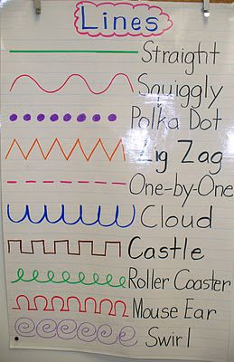

Clean up:
- When you have finished put collage on counter
- Put scissors and glue back in your desk
- Put unused paper back on the pile and recycle scraps
- Pick up floor around your desk
- If done early read or work in activity book

Assessment:
The teacher will listen to the students’ responses and discussions with each other to gauge their understanding of the different types of lines and what the focal point of an art piece is. As the students finish making the collages and hand in their completed collages to be displayed, the teacher will ask the student what the focal point of an art piece is and to name a type of line that they used.

Reflection:
I think that this lesson was decent over all. The Lines that Wiggle book was good, because it connected to the lesson, but there may be a more interesting book out there. I liked creating the anchor chart with the kids instead of having it prepared before hand. They had a lot of good ideas and I think supplying the line types kept them more engaged. They classified the lines easily. Another idea would be to have them draw different types of line on their own marker board and then sharing one with the group while adding the other student’s ideas to their boards.
The finding lines around the room activity help cement the idea that there are different types of line. I think that it would have helped to give my own example of the line to they were to find to help them understand what it may look like in real life. During this time the kids were distracted by the camera video taping them. They were redirected, but it was just to tempting for some of them. That wouldn’t be a factor in the future though.
Teaching focal point was interesting because it was a brand new concept. I think that they got it based on listening to their answers and being able to correctly use the term focal point. The turn and talks used at this point let them move some and let everyone share their idea. If this were used again I would want to display the pictures on the ActivBoard so I could walk and monitor the back row of students better. It wasn’t quite working today so the blown up pictures worked, but it was not ideal.
The collage project went well and the end products were great. I would keep having the students help handout paper. A thought would be to have the steps posted, but I’m not sure if that would decrease the creativity and individuality of the final projects. Part way in, the practicum teacher brought out scrapbooking scissors to help the kids cut the different types of line and the kids all really like using them, but I don’t think I would allow these scissors to be used in the future. Kids stopped cutting lines and started making shapes. They also did not have to think as much about what lines they were using in their collages. Finally, I want to post the cleanup expectations so the kids know what to do as soon as they are done. Then they won’t ask repeatedly.

